**SSH LAB EXERCISE**

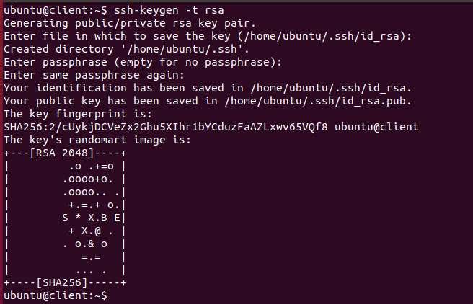

Generated authentication keys on client computer.

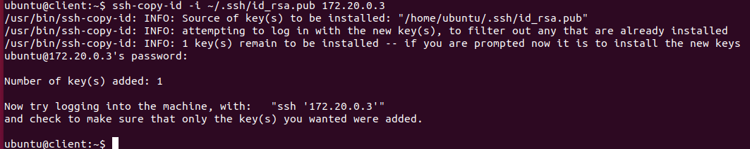

SSH has been setup on server for user to use authentication keys.

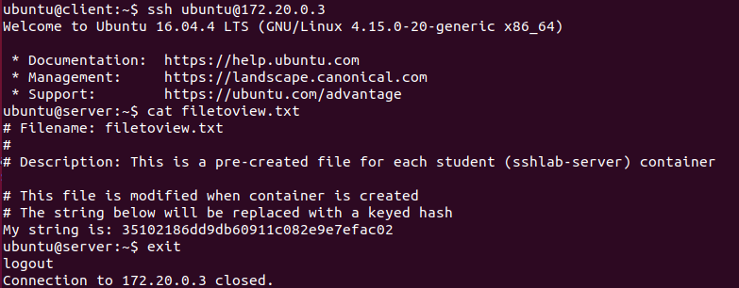

Connected with SSH to server and viewed filetoview.txt

**Telnet Lab Exercise**



Ran ifconfig to find server’s ip address

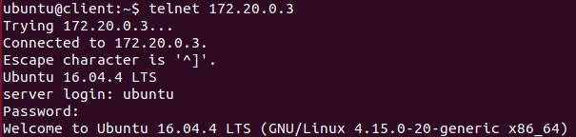

Telnet to server ip address and logged in with credentials.

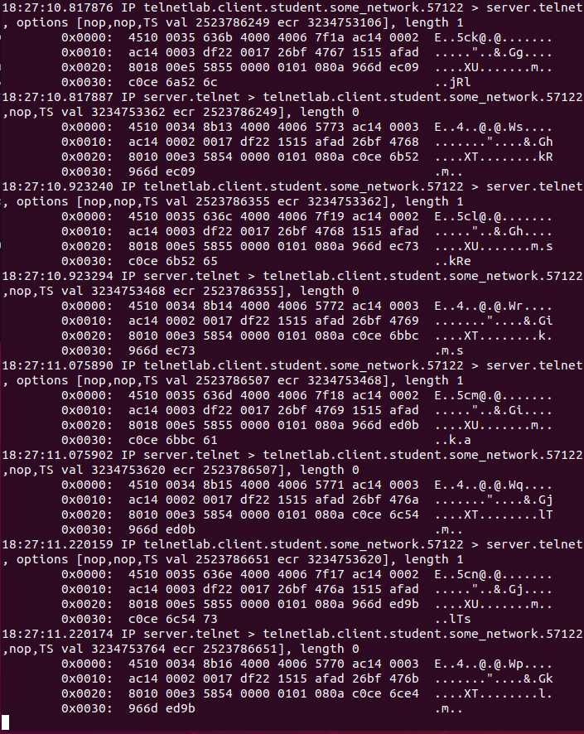

Showing tcp dump from server. When client tries typing it password, no discernable info can be extracted from the network traffic.

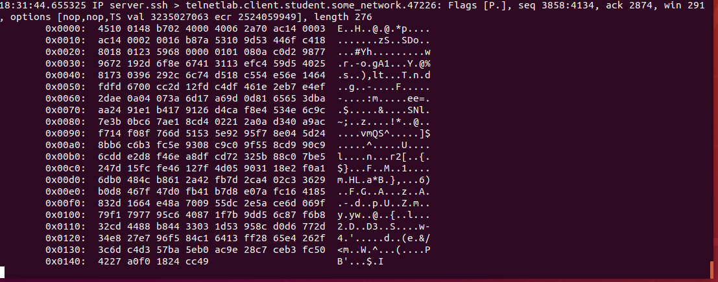

Showing tcp dump from server. When client asked to view filetoview.txt, no readable plain text is observed from just the network traffic alone.